MILESTONE ACADEMY
VACATION HOME-WORK
SUBMISSION DATE – 17.06.19 CLASS – VII PC/MS/2019-20/VII/012
-------------------------------------------------------------------------------------------------------------------------------------------
ENGLISH – 1. Write an account on Pilots. Write on the basis of hint questions provided to you.
Hints :- 1) What is the job of a Pilot?
2) If you become a pilot, what kind of aeroplanes would you want to fly and what
would be your responsibility?
3) How would you communicate with your crew?
2. Make an English dictionary, 3 words of each alphabet along with their meanings and
illustration for 60 words at least.
3. Write a letter to your grandparents inviting them to spend the summer vacation
with you and other family members.
4. Today is your birthday. Write a diary entry on how you want to spent the day.
5. Complete this crossword using the given clues.
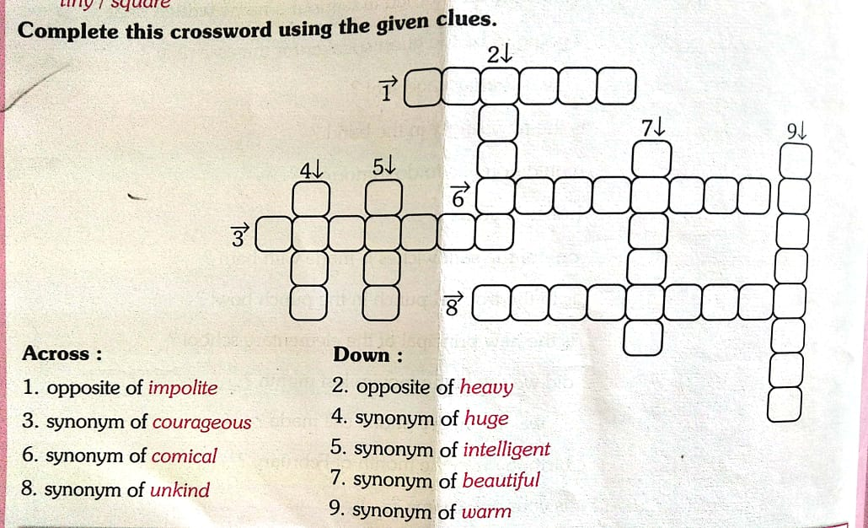

6. Find ten common nouns in the wordsearch. Write them against their clues.
1. Insect
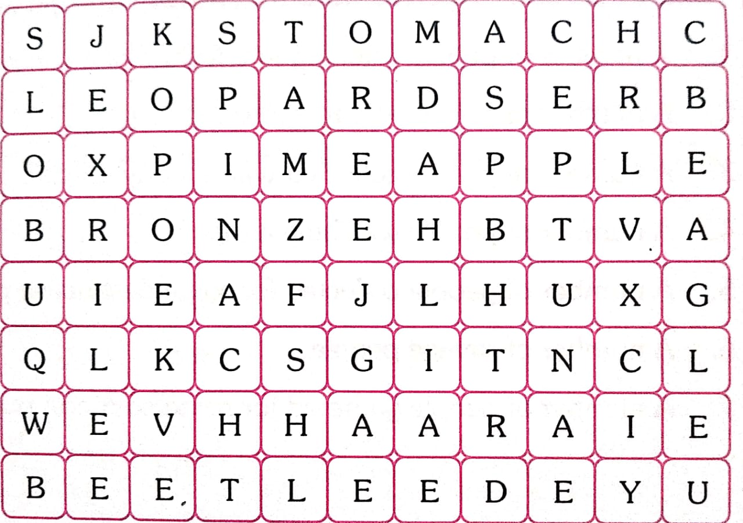
2. Fish
3. Body Part
4. Fruit
5. Flower
6. Big Cat
7. Vegetable
8. Bird
9. Alloy

HINDI - 1- #< ] ;ksx#<+ ] ;kSfxd ] ns'kh o fons'kh 'kCnkas ds pkj & pkj mnkgj.k fyf[k, A
2- vius Ldwy esa vk;ksftr LokLF; esys dk o.kZu djrs gq, vius cM+s HkkbZ dks i= fyf[k, A
3- LokLF; vf/kdkjh dks i= fy[kdj [kkn~; inkFkksZ esa gks jgh feykoV dh f”kdk;r dhft, A
4- vius {ks= ds fctyh vf/kdkjh dks ckj & ckj fctyh pys tkus dh f”kdk;r djrs gq, i= fyf[k,A
5- vuqPNsn ys[ku & 1- esjh izFke jsy ;k=k 2- [ksy vkSj gekjk LokLF;
3- i;kZoj.k vlarqyu & mÙrjnk;h dkSu \
- vius ikB~; iqLrd ds ikBksa ls izR;sd v{kjksa ds dfBu “kCn <wa<dj muds vFkZ fy[kdj
“kCndks”k (Dictionary) cukb,A

- fuEufyf[kr “kCnksa dh laf/k djsa A
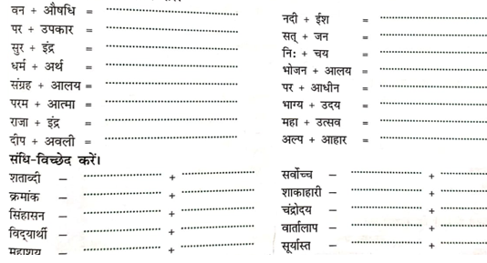

SOCIAL SCIENCE –1 Prepare 20 objective questions & answers each from History Ch-1 & 2,
Geography Ch- 2 & 3 and Civics Ch 1 & 2 .
CIVICS – Ch. – 2 Role of the Government in Health. .[Make an illustrated project]
GEOGRAPHY – (i) Ch. – 2 Inside our Earth.[ Make an illustrated project]

HISTORY – Prepare PPT or an illustrated report on
1) Administration in the kingdom (L-2).
- Administration in the empire(L-2).

SANSKRIT – 1- ydkj& 1- yV~ ydkj 2- yX ydkj 3- y`Vydkj 4- yksV~ ydkj
2- /kkrq & pj~ ] d` ] ol~ ] ik ¼fic½ ] j{k~ ] [kkn~
3- laKk dkjd @fir` ] unh ] okfj ] e/kq
4- loZuke 'kCn & 1-,rr~ rhuks fyaxks eas 2- rr~ rhuks fyaxks esa
5- vO;; & v/k% ] vfi ] v/kquk ] vye~ ] 'o% ] g;% dk vFkZ
6- vuqNsn ys[ku & n”k okD;kfu jp;r
- ee fo|ky;%
eHtw"kk & ¼izkpk;Z% ] izdks"B% ] m|kue~ ] Nk=k% ] ØhM+k{ksee~ ] v/;kidk% ]
fo"k;k% okf"kZdksRlo% ] lkaLd`frd dk;ZØe% ] iqLrdky;% ½
- m|kue~
eHtw"kk & ¼o`{kk% ] u|% ] i;kZoj.ka ] x`gs ] iq"ikf.k ] Qykfu ] [kxk% ]
fofo/kkjX% HkzefUr ] tuk% ] 'kq}e~ ½
MATHS – 1. You have 100/- Rs. with you. Find the number of ways you can invest it in the various
investment schemes. Find the best investment scheme.
2. Find :-
- -9-(-6) = …………… 3) 6 – (-8) = ……………
- (-36) x (-9) = …………. 4) 30 x (-23) + 30 x 14 = ………..
3) The sum of two integer is -6. If one of them is 2. Find the other.
4) What must be subtracted from -1 to get -6?
5) Divide -105 by 21?
6) The difference of an integer ‘a’ and -6 is 4. Find the value of ‘a’.
7) What will be the sign of the product if we multiply 90 negative integers and 9 positive?
8) What will be the sign of product if we multiply 103 negative integers and 65 positive integers?
9) Identify the property
1) 3 x 5 = 5 x 3 2) -3 x (4+6) = -3 x 4 + 6 x -3
10) A certain freezing process requires that room temperature be lowered from 40⁰c at the rate
of 5⁰c per hour. What will be the room temperature 12 hr. after the process begins?

11) Evaluate :-
1) $\frac{1}{2}+\left(-\frac{3}{2}\right)+\frac{1}{4}$ 2) $\frac{1}{3}-\frac{1}{5}—\frac{1}{2}$
12) Mr. Murrin is 160 cm tall and his brother Tom is $\frac{7}{8}$ as tall as him. How tall is Tom?
13) Find the perimeter of the figure given below :-
2/3 cm

3/2 cm

14) If $\frac{1}{3}$ of a sum of money is Rs. 21. What is the sum of money?
15) Write all the integers between the given pairs in ascending and descending order:-

S.NO | Integers | Ascending order | Descending order
1 | 0 and 6
2 | -2 and 2
3 | -8 and -13
4 | -40 and -32

16) Write all the integers between the given pairs in ascending and descending order:
S.NO | Integers | Ascending order | Descending order
1 | -60, 310, 0, -215, 29
2 | -200, 154, -6, 315
3 | -300, 250, -175, 150, -100
4 | -95, -85, 65, 35, -75
5 | 176, -331, 117, -115, 101
6 | 210, -305, -106, 216, -75

17) State whether true or false. Do working and give examples to prove your point.

- Sum of any integers is always greater than  Their difference | - (-28+46) $≠$ 46 + (-28)
- Additive inverse of -119 is 119 | - On adding any integer with its additive inverse, we get the additive identity.

18) Write a pair of integers for which the following statements are true.

- Sum is zero | - Difference is zero
- Sum is a negative number | - Difference is a negative number.

SCIENCE – 1. From Fibre to fabric [collect pictures of different fabrics & describe]
2. Collect the names of countries to which silk and wool is exported from India and also
imported from. Point out these countries in world map.
3.Point out regions where silk and wool are abundantly produced in India in physical
map of India.
4 Paste photographs of examples of :- Saprotrophs, Insectivorous plants, Parasites &
Autotrophs.
5. Label this diagram showing digestive system in human beings.

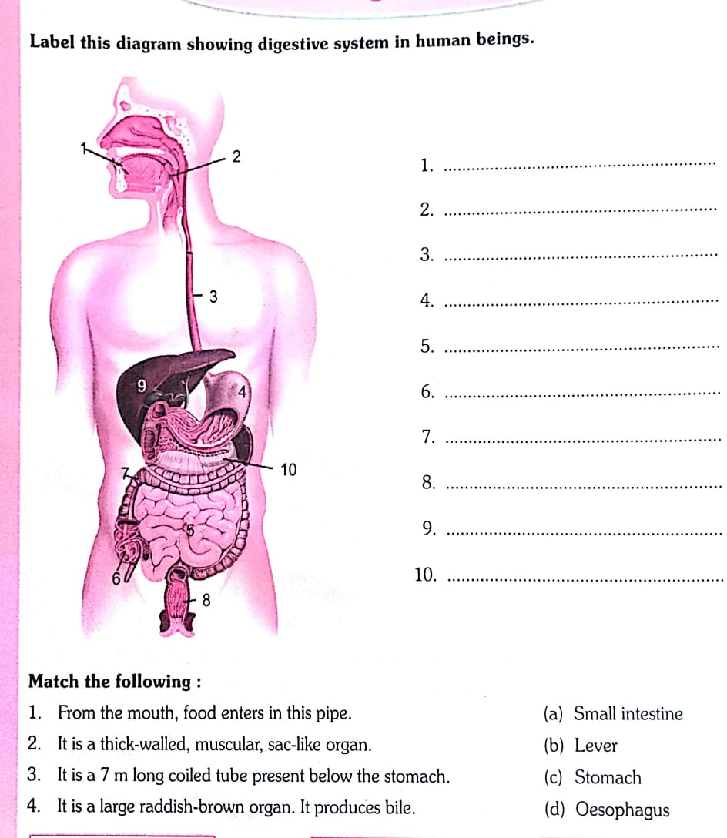
- Search and write symbols for the given elements to complete the table.
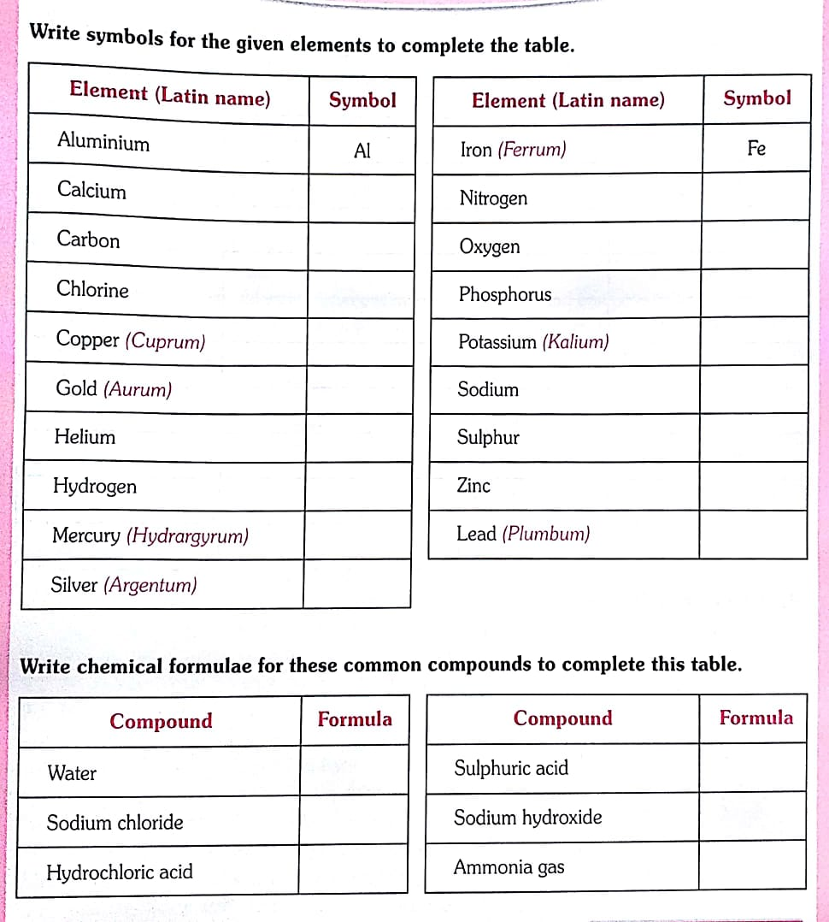

- Write chemical formulae for these common compounds to complete this table.

COMPUTER – Find out the names of 10 movies that are based on robots collect the
pictures and make a chart.

CREATIVE EXPRESSION - “My favourite season”
Record and write the conversation done with your favourite family member or friend during summer vacation :
Eg. - Written conversation
Grandma – Very Good Morning to you.
Grand daughter / son - Good morning Grandma.
Today what a chirpy morning it is !
Grandma - So how are you making this morning beautiful?
Grand daughter/ son - After breakfast I am visiting my friends place to play.

LIFE SKILLS- As a member of your family, what kind of responsibilities you would like to undertake?
Discuss with the members of your family and make a list of these responsibilities.

